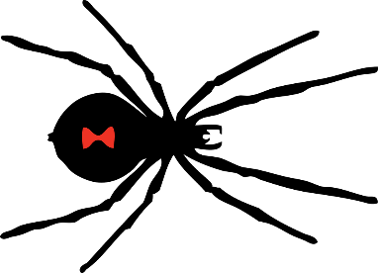
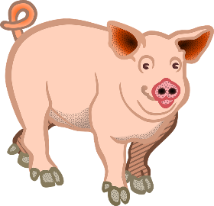
Animals Facts
PIGS
Despite what many believe, pigs are not dirty animals. They are actually quite clean. They have a habit of rolling in mud to cool off but if these pink grunters live in cool, covered environments, they stay very clean.
The pig, which lives to roughly 8 years of age, is also known as a hog or swine. Male pigs of are called boars; female pigs are called sows. Pigs provide valuable products to humans, including pork, leather, glue, fertilizer, even medicines.
Fully grown, these greedy gobblers can grow to between 140 and 300 kilograms. Pigs have poor eyesight, but a great sense of smell. The pig’s nostrils are on its leathery snout, which the porky piglet uses to search for food.
There are around 2 billion pigs in the world and they are among the smartest of all domesticated animals, even smarter than dogs!

BLACK WIDOW SPIDERS
The American black widow is a poisonous arachnid (spider) that has a skeleton on the outside of its body (exo-skeleton) and 8 legs. Their deadly poison is said to be 15 times stronger than rattlesnake venom!
The name “black widow” comes from the female’s habit of eating the male! The female cobwebbed critter is approximately 3.8cm long. The male is about half the female’s size at 1.9cm long.
The web-spinning spider senses vibrations on its web. When an unlucky intruder gets trapped, the spider immediately begins weaving its glue-like webbing around it. Insects such as flies, mosquitoes, or even larger prey like grasshoppers are typically caught. Once captured, the black widow injects its victims with poison, paralyzing them.
These nasty monsters can leave painful, poisonous bites on humans but are rarely fatal.

© Mr A, Mr C and Mr D Present 2020
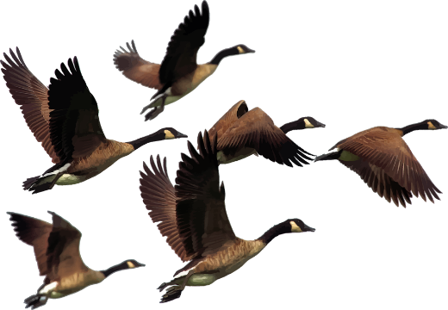
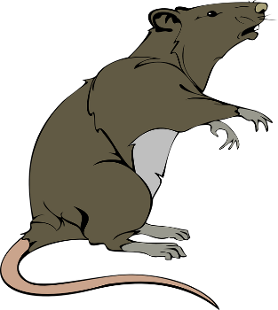
Animals Facts
RATS
The rat is smart and quick. These restless rodents have teeth so sharp they can cut through wire or even glass. They constantly grow so they have to chew on wood to keep them sort. They can also squeeze through tiny holes. These brown beasts are usually about 10 to 14 inches long, including their tails.
Rats can have up to 20 babies at once and it is thought that there are about 81 million rats in the U.K. (more than there are people).
Some people like rats and keep them as pets. Pet rats are smart and social. They can learn tricks and will come when called. Many people do not like these pesky pets because they chew up wires, get into food and can carry diseases.
GEESE
Geese is actually the name given to females and gander is the name for a male. Their young are known as goslings and as a group they are known to be a gaggle of geese!
They are part of the swan family and are known for their long necks and good eyesight. The way their eyes are structured allows them to see things in much finer detail at a further distance than humans. These feathery birds can even control each eye independently of each other. Along with this ability, geese are able to sleep with one eye open!
Some of these large creatures grow a wingspan of up to 2 metres in size and are capable of flying up to 2,500km per day if the weather is good. They can often be seen flying in a special formation where one goose leads. When it gets tired another guiding goose takes its place and they help each other to stay together!

© Mr A, Mr C and Mr D Present 2020
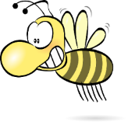
Name: ______________________
Date: _______________________
Our Non-Fiction Buzz Words

Animal | PIGS | BLACK WIDOW | RATS | GEESE
The Universal Article | The pig
The Generic  Number | - lives to roughly 8 years of age  - can grow to between 140 and 300 kilograms  - around 2 billion pigs in the world
The Artful Synonyms | - pink grunters  - hogs/swine  - greedy gobblers  - porky piglets
Technical Vocabulary | - environments  - sow (female) and boar (male)  - leather, glue, fertilizer and medicines  - snout  - domesticated
© Mr A, Mr C and Mr D Present 2020

